CSS

Hikes SQL  
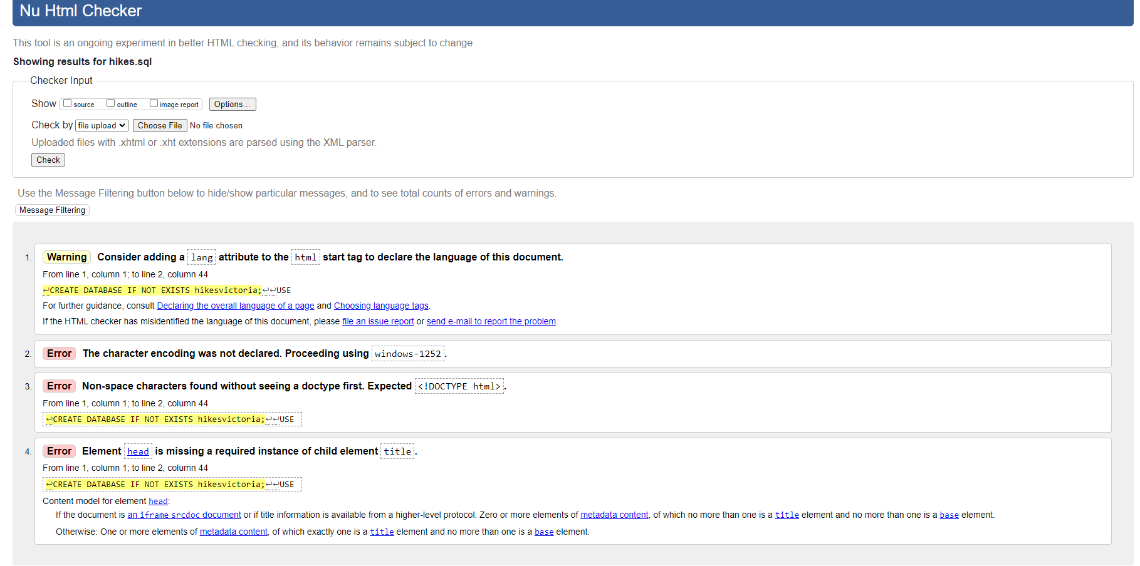  
Hikes PHP

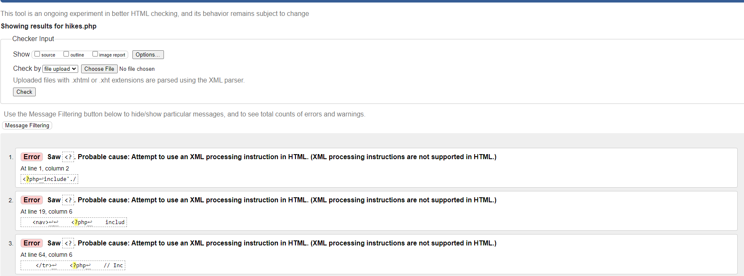  
  
  
// The rest of the following files contain errors, including the “Includes folder” container db_connect, header, nav and footer//